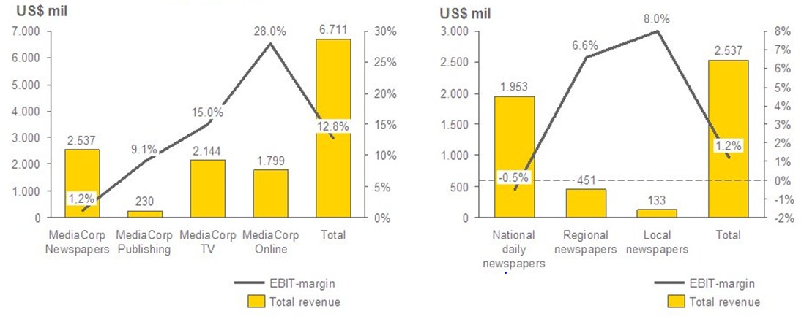

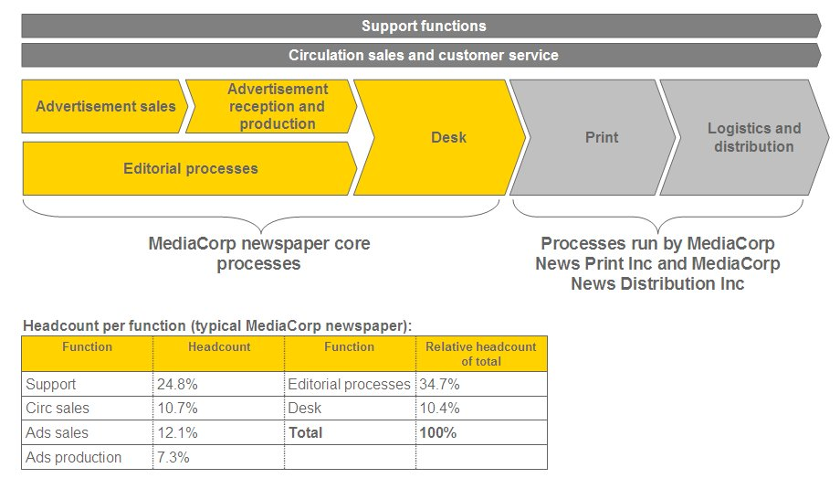

## Additional information from interviews

From brief interviews with clients and members of EY familiar with the industry, you find out that:

* Subject matter experts tell you that it is a known fact in the industry that most newspapers struggle nowadays. This is due not only to decreasing advertisement sales but also to the increasingly important presence of online newspapers, which has substantially reduced the number of readers (and therfore the circulation). The national daily newspapers struggle the most with circulation, while certain niche newspapers have increased their readership. The readership of regional/local newspapers is still quite stable.
* There is fierce competition in the national daily newspaper market. Prices per issue have been stable the last five years, and increasing prices seems like a limited possibility.
* All of MediaCorp’s national daily newspapers, most of the regional newspapers and some local newspapers have online editions. The online editions of the newspapers are organized within each newspaper.
* Due to stagnation of printed newspaper demand, all companies already focus heavily on development of their online newspapers and additional online products. However, product development is time-consuming, and with the current resources they consider it difficult to increase the speed of online product development. “It is also a question of core processes,” John Rapport, CEO of Media Times, says. “Although we all look for development in the online segment, most of us (the employees in Media Times) still are journalists, and developing quality content is what we are supposed to do.”